**BUSINESS REPORT**

**STRATEGY**

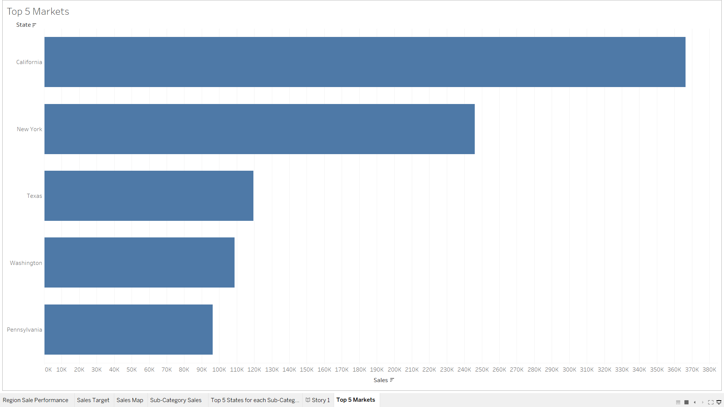

From the image above, the top 5 states/markets for our products with the highest sales are:

* California with total sales of $366,384 in the last 24 months
* New York with total sales of $246,088 in the last 24 months
* Texas with total sales of $119,563 in the last 24 months
* Washington with total sales of $108,770 in the last 24 months
* Pennsylvania with total sales of $96,266 in the last 24 months

In the last 24 months, from 2017 to 2019; sales in California also located in the West Region has increased by 65.5% from $88,444 in 2017 to $146,388 in 2019. Which is positive for our store. The state of California also brought in the highest profit with $63,743. 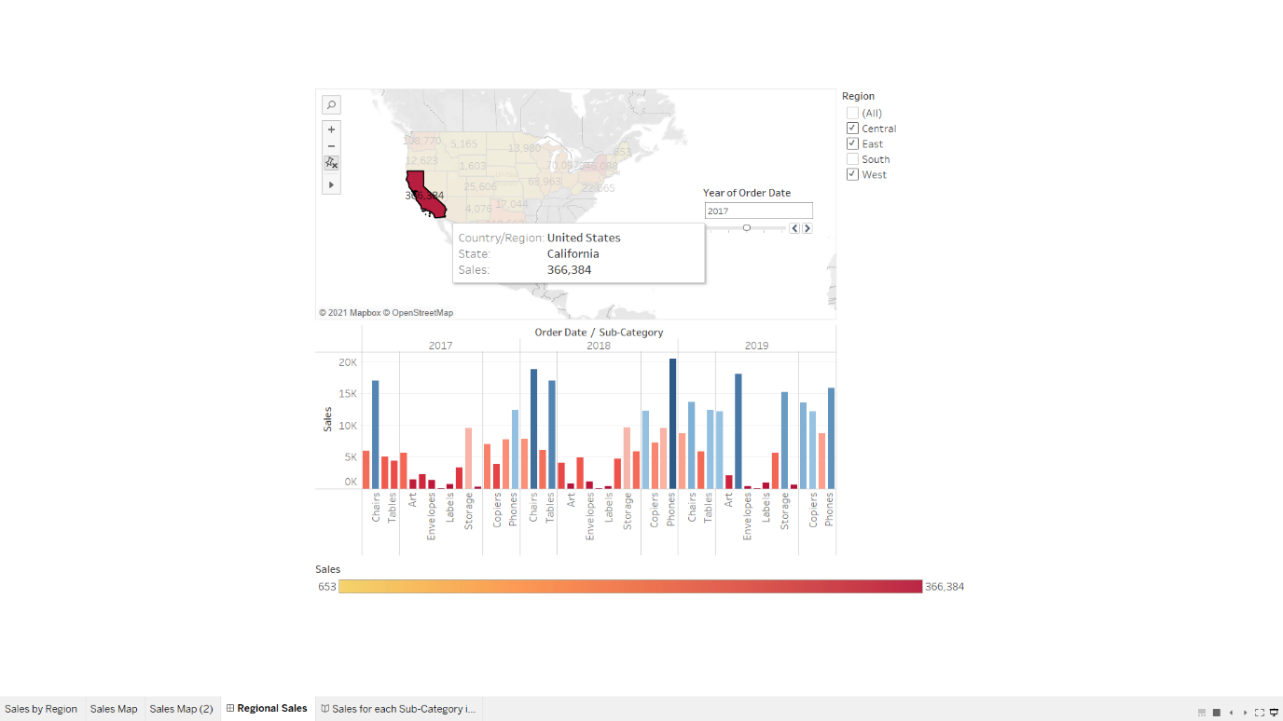

The state of California is where the Silicon Valley is located and it isn’t very surprising to see that it is where most of the sales of our product categories come from. Though 2017 wasn’t really the best year for sales within the state but moving forward to 2018, 2019 sales of our products in the sub-category increased significantly especially 2019 which is its best year so far.

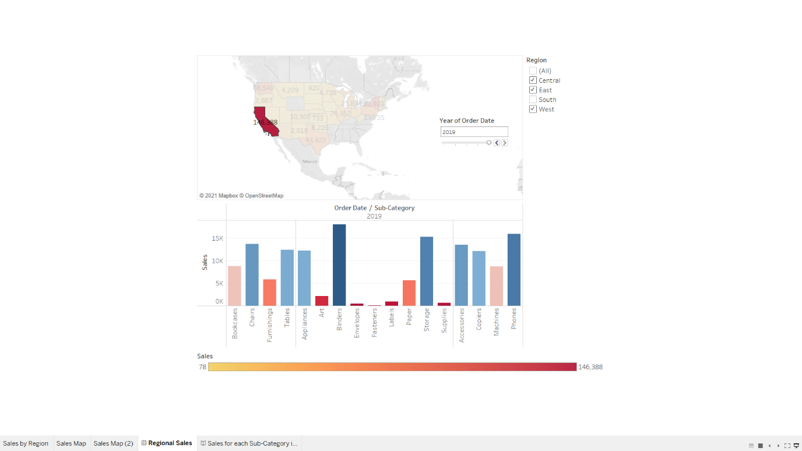

In terms of region, the west had the highest number of sales with California contributing majority of its sales. So, you can see how powerful the sales in California are.

California alone has the highest sales in all 16 products in the sub-category; although in some states, the sales of these products are not as high as you may think so I suggest we pull resources from underperforming products in this state.

* Paper, I believe the more access we have to the internet and document sharing platform, the need for paper will become less and less especially from a place like Silicon Valley where a majority of companies are.
* Envelopes, still iterating the point earlier, the more the tech world moves forward, the less we need these things. I suggest we stop selling this product in every state as they have low sales.
* Art, areas like these aren’t too appreciative to art so I suggest we stop selling art products in our top 5 states as it doesn’t have much sales.

The state of New York comes in 2nd with sales increasing by approximately 17% in the last 24 Months from $80,321 in 2017 to $93,923 in 2019. The state of New York also had the 2nd highest profits with a total of $60,290.

In New York, we should focus more on these products

* Machines, as they have had steady increase in sales in the last 24 months and are currently 2nd to California with $127 difference in sales
* Appliances
* Binders
* Chairs
* Furnishings
* Phones and
* Storage

On the other hand. Though Texas was in the top 5 states with highest sales with sales increasing by approximately 26% from $34,455 in 2017 to $43,422 in 2019. They were also the state with the highest loss that kept on growing to about $16,594 in the last 24 months. 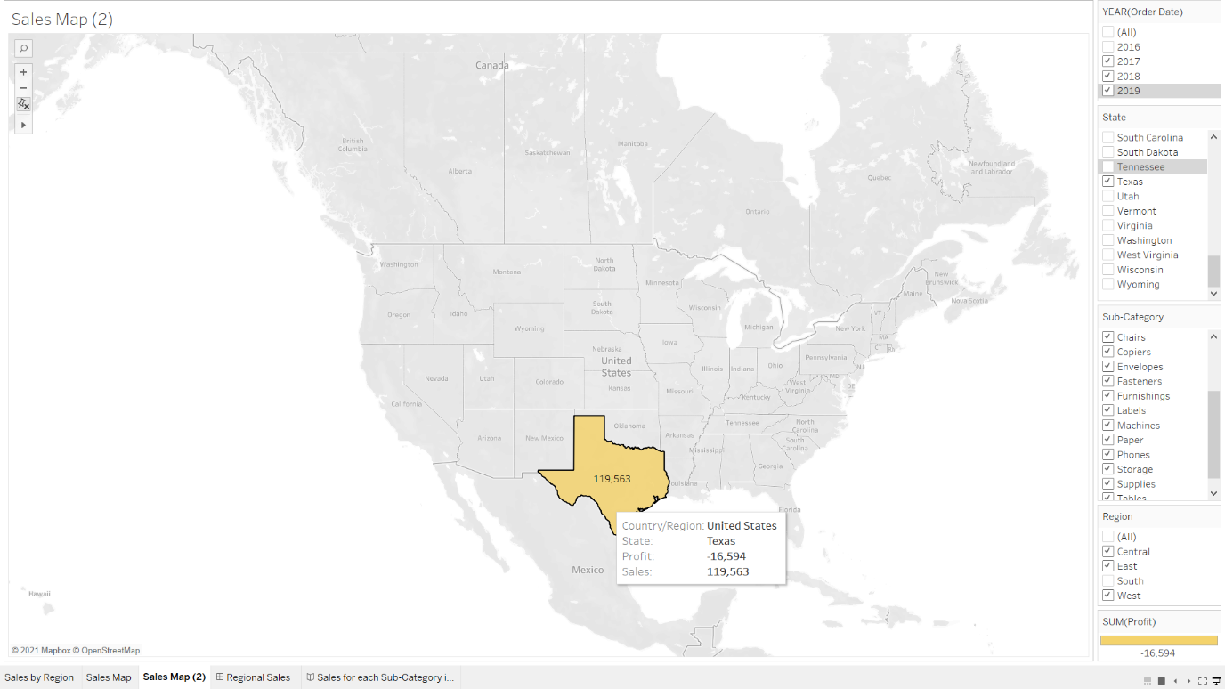

In 2017, almost all the categories except technology and sub-categories except phones made sales above $30 and most of them made losses of at least $400 except phones which made sales of about $9,939 and profit of about 1,285. The rest of the years gradually improve with some significant growth in sales of some sub-categories e.g., Bookcases which saw a substantial increase in sales from $4,726 to $5,489 and some of the other products had increase in sales but incurred more losses. So, I dug a little deeper and discovered that our store in Texas had given the highest number of discounts with a total of $243.8 and this may be due to the possibility that in order to lure more customers, our store in Texas had to give discounts but apparently the whole idea backfired. I would suggest not supplying any products to the state of Texas and instead push more resources into developing states like Washington.

Washington, 4th highest state in sales has seen an increase in sales by approximately 180% from $23,416 to $65,540 in the last 24 Months. 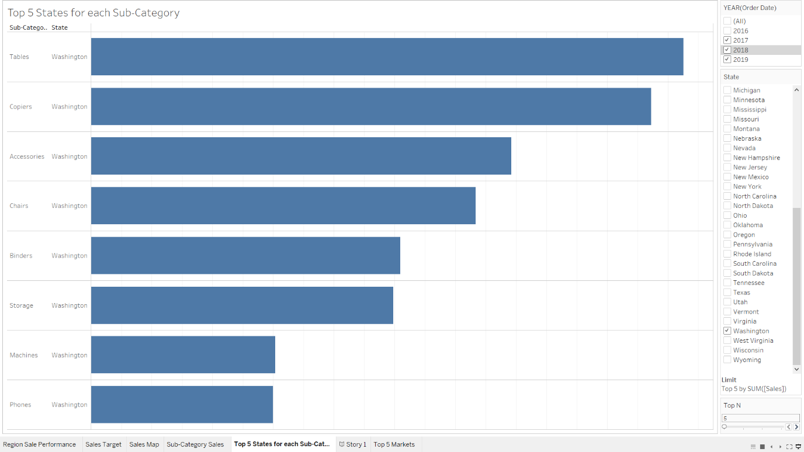

If we decide to pull resources from underperforming states like Texas, Washington will be a good state to spend advertising dollars on. We see categories like office supply have significant increase in sales in the last 24 months. In Washington, the top products from the image above are:

* Table
* Copiers
* Accessories
* Chairs
* Binders
* Storage
* Machines and
* Phones

All the products have seen their sales increase by at least $2000. I highly suggest that we advertise more in this location as it has a high potential for future sales.

Lastly, Pennsylvania saw their sales increase by approximately 108% in the last 24 months from $20,511 to $42,688. Pennsylvania struggled with sales from 2018-2019. Although they started strong with products like

* Bookcases
* Chairs
* Furnishing
* Storage
* Phones

Then all of a sudden, the sales of this products sharply declined from $3,737 to $341 which is suspicious and calls for more investigation. Although our stores in Pennsylvania tried to improve their sales by offering discounts but it didn’t really workout. In Pennsylvania, I highly suggest we stop the sales of underperforming products and spend more advertising money on products that are performing better. In some cases, Pennsylvania is the among the top 5 states with highest sales for products in the sub-category such as

* Appliances, where they came in 3rd behind California and New York with sales of about $3,647
* Binders, where they came in 4th behind California, New York and Washington with sales of about $4,961
* Chairs, where they came in 3rd behind California and New York with sales of about $13,144
* Phones, where they came in 3rd behind California and New York with sales of about $15,266. One thing to note about the phones sub-category is that when Pennsylvania was struggling to make sales, the sale of phones was okay. 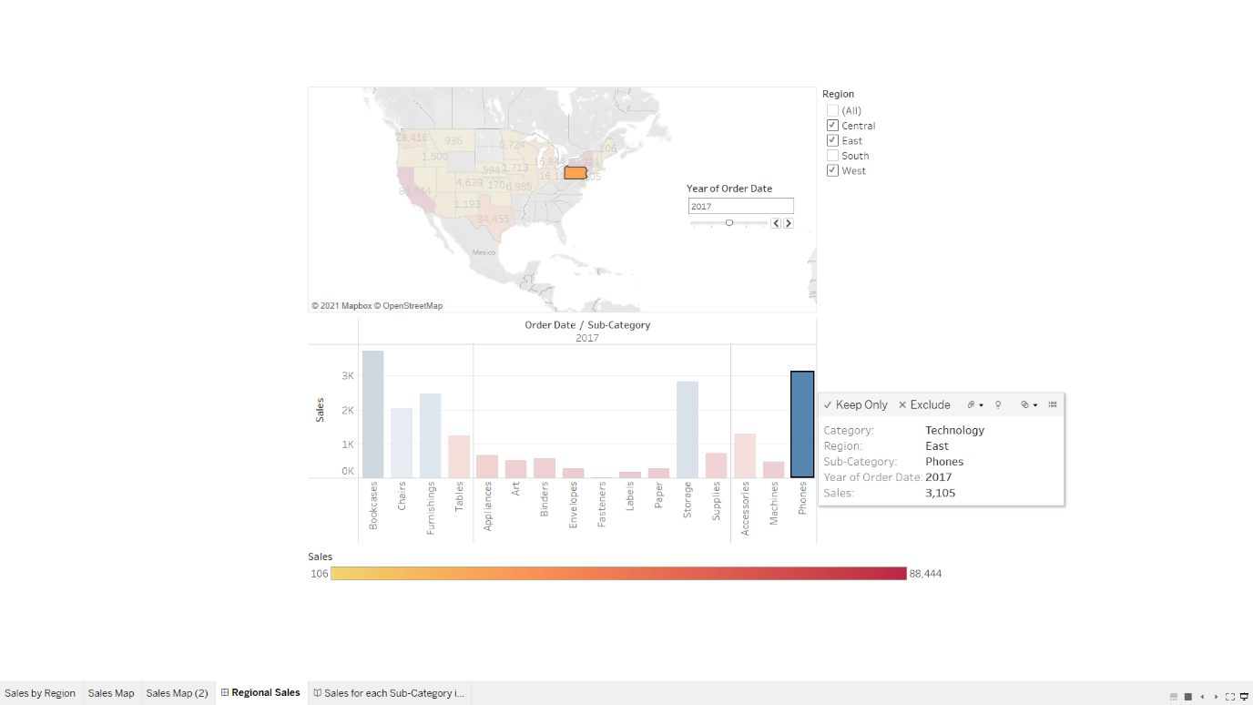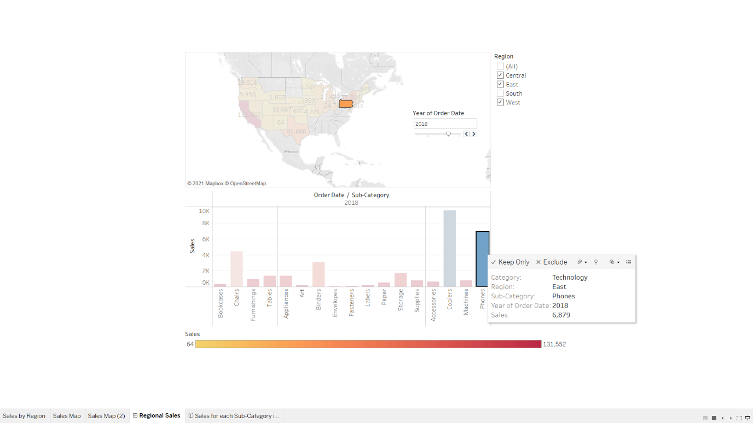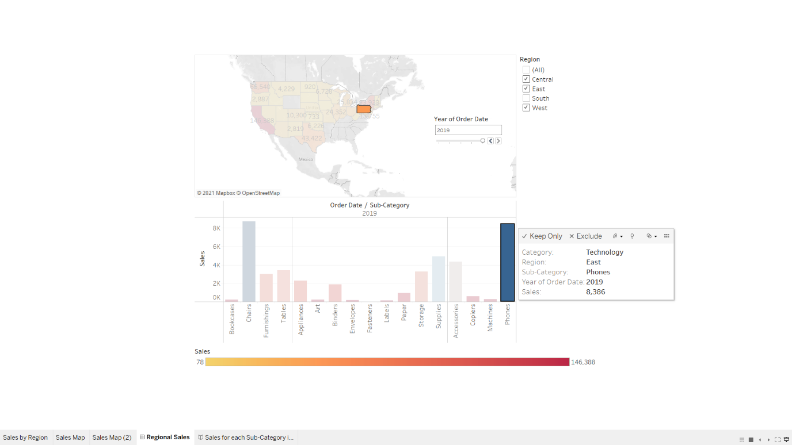
* Supplies, just 2nd behind California with sales of about $5,688 and the difference of about $845 between them.

From these findings, our store Pennsylvania has the capability to be among our best performing states especially if we spend more on advertising these aforementioned products.